11.81: a) Taking torques about the contact point on the ground, The ground exerts a vertical
force on the pole, of magnitude 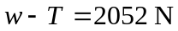. b) The factor of 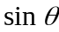appears in both terms of the equation representing the balancing of torques, and cancels.

